Nama : Maulana Yusuf

NIM : 17090096

Kelas : 5B

Praktikum 2

- Source Code

Web.php → application/controllers

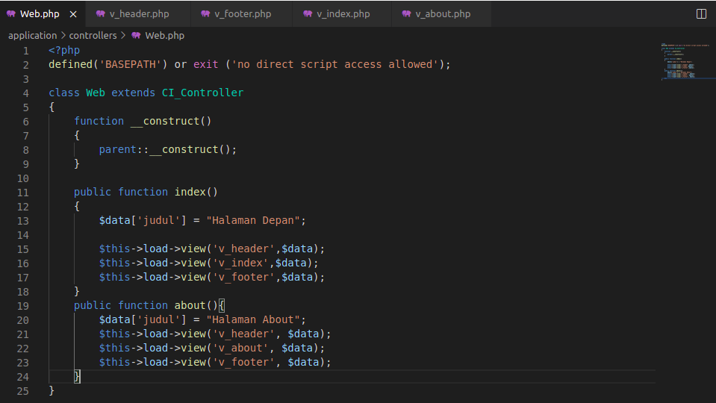

v_header.php → application/views
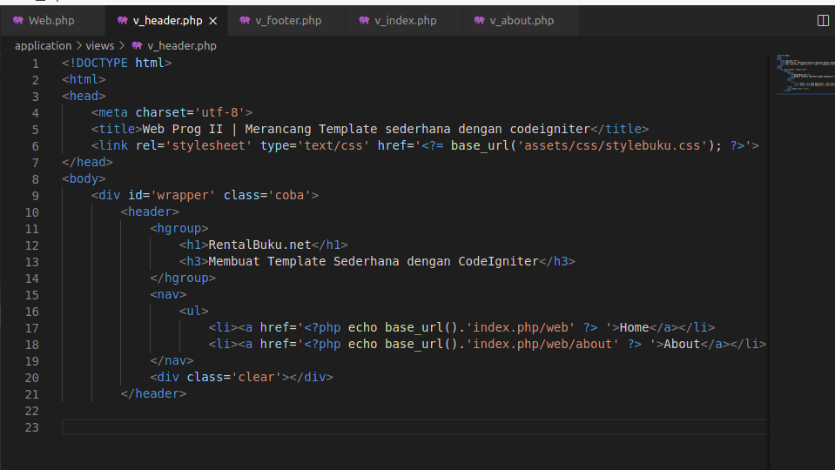

v_footer.php → application/views
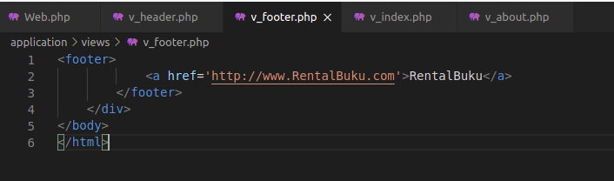

v_index.php →application/views

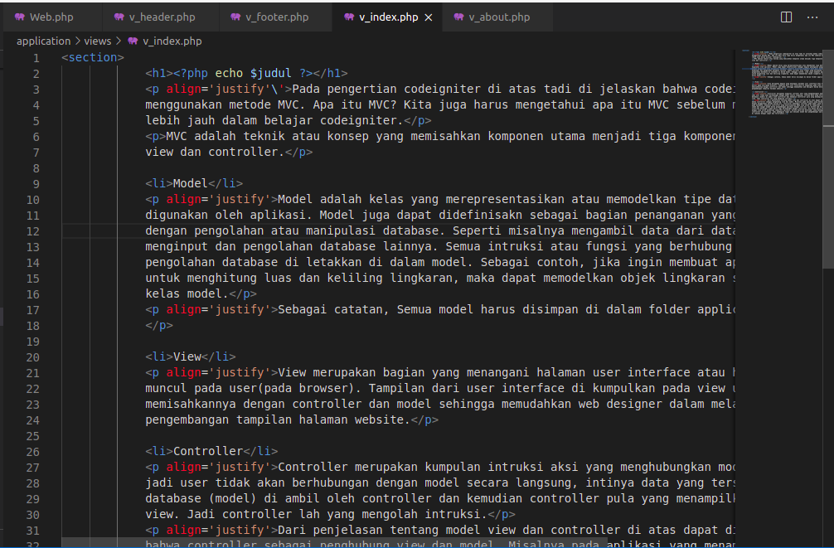

v_about.php → application/views
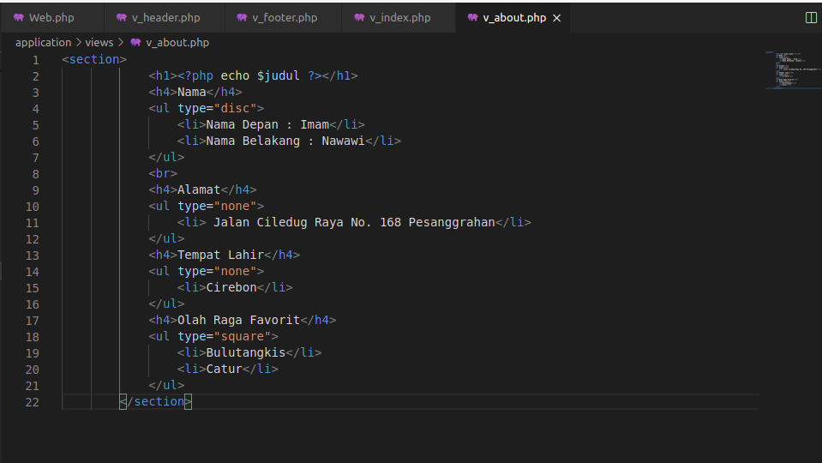

- Hasil URL

http://localhost/pustaka-booking/web/
http://localhost/pustaka-booking/web/about

- Capture Hasil

